**Ashcan School**

The Ashcan School was a group of American artists that began exhibiting together in the early twentieth century and advocated for total freedom in style and subject matter. Also known as Urban Realists because of their focus on urban, public spaces including trains, streets and parks, restaurants and bars, and other spaces of popular entertainment, Ashcan members included Robert Henri, John Sloan, George Luks, William Glackens, Everett Shinn, and George Bellows. ‘Ashcan’ was initially a pejorative term applied to the group because they employed dark colours and painterly, unblended brushstrokes, which were thought to make their works appear dirty or unfinished. The Ashcan School was initially associated with a secessionist art group called The Eight, which also included postimpressionists Arthur B. Davies, Maurice Prendergast, and Ernest Lawson. The Eight rebelled against the National Academy of Design, the principal art school and host of prestigious juried exhibitions in New York, because they sought greater stylistic freedom and more control over their exhibition opportunities. Implicitly, the Ashcan painters also rebelled against The Ten, a group of American Impressionists, because they thought their predecessors’ works were too delicate in style and genteel in subject matter.

Many of the Ashcan artists began their careers as newspaper illustrators in Philadelphia, where they learned to work quickly, depicting current events and locales. Many of the Ashcan artists were interested in progressive-era politics and social issues, which they explored to varying degrees in paintings, drawings, and prints. As a teacher and writer, Henri became the de facto leader. He is best known as a portraitist and made paintings of lower-class children, which are characterized by their attention to the personality and dignity of the sitters. Sloan’s role as the art editor and illustrator of *The Masses*, a socialist magazine, gave him a platform to express his sympathy for the plight of the working poor, whereas his paintings offered more light-hearted views of modern life. Despite the Ashcan School’s early reputation for rebelliousness, these artists’ styles appeared retrograde after the American public encountered Cubism, Fauvism, and other more abstract modernist styles at the Armory Show of 1913.

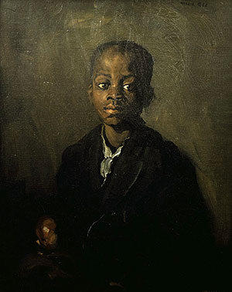

Robert Henri, *Willie Gee*, 1904, oil on canvas

<http://www.newarkmuseum.org/popup_page.aspx?id=4982>

**References and further reading**

Coyle, H. (2007) *John Sloan's New York*. Wilmington: Delaware Art Museum, in association with Yale University Press.

Hills, P. (1980) ‘John Sloan's Images of Working-Class Women: A Case Study of the Roles and Interrelationships of Politics, Personality, and Patrons in the Development of Sloan's Art, 1905–16’, *Prospects* 5: 157-196.

Homer, W. I. (1969) *Robert Henri and His Circle*. Ithaca, NY: Cornell University Press.

Kennedy, E. and Brownlee, P.J. (2009) *The Eight and American Modernisms*. New Britain, CT: New Britain Museum of American Art; Milwaukee: Milwaukee Art Museum; Chicago: Terra Foundation for American Art, distributed by the University of Chicago Press.

Tottis, J. (2007) *Life’s Pleasures: The Ashcan Artists’ Brush with Leisure, 1895-1925*. London: Merrell.

Zurier, R. (1995) *Metropolitan Lives: The Ashcan Artists and their New York*. Washington: National Museum of American Art, in association with Norton.